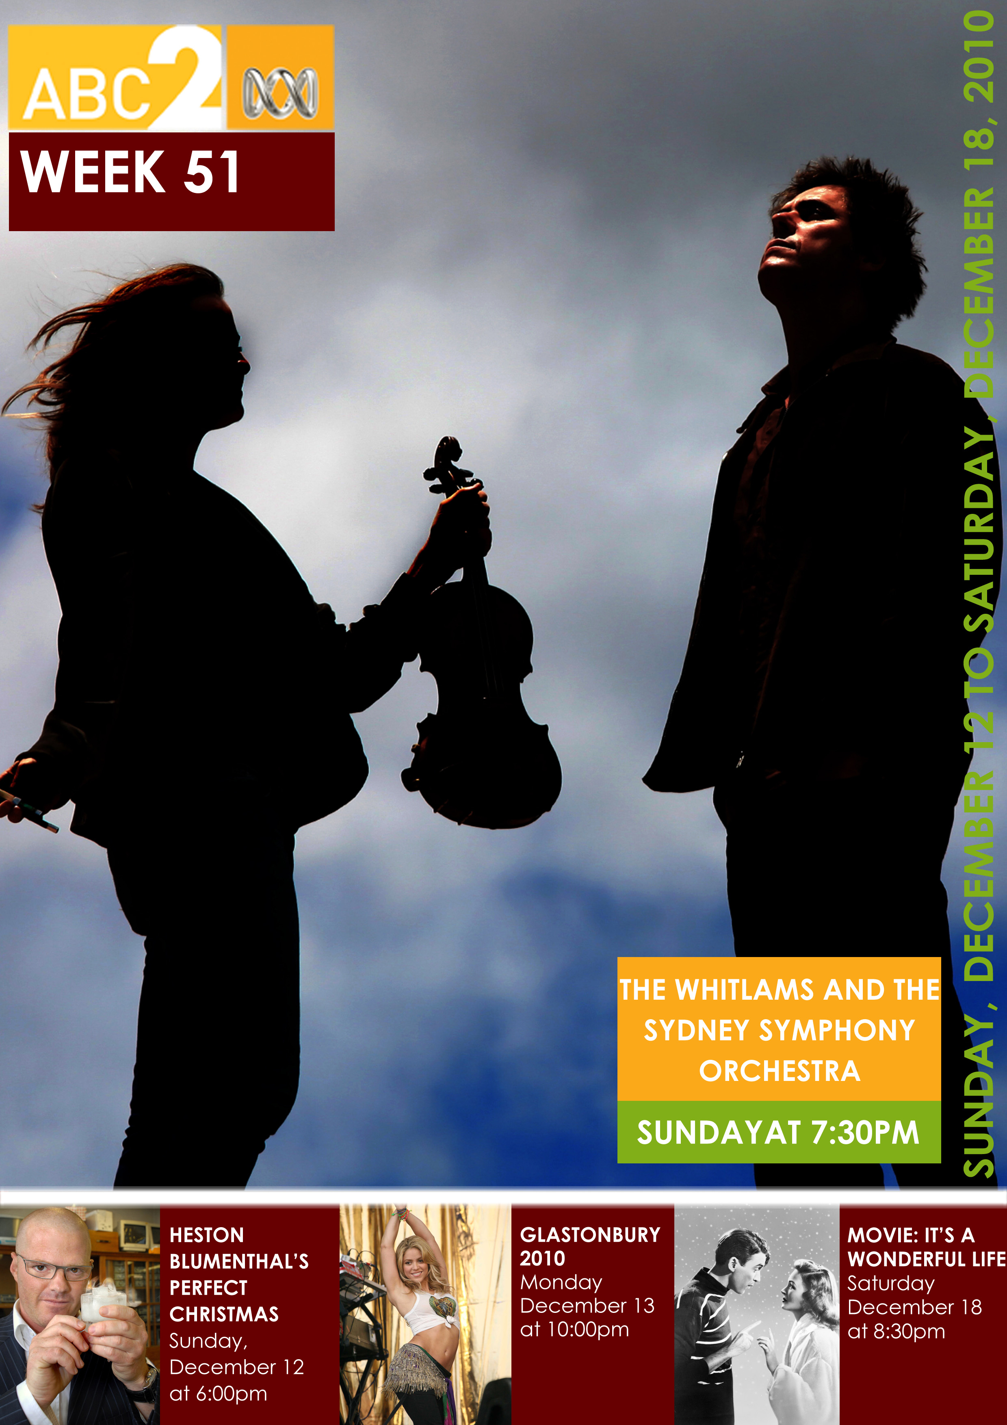
Index
Program Highlights 1
Heston Blumenthal's Perfect Christmas 1
The Whitlams And The Sydney Symphony Orchestra 2
School Of Comedy 3
Rude Boy Food 4
The White Stripes: Under Great White Northern Lights 5
Republic Of Doyle 6
Watch Out For… 7
Glastonbury 2010: Stevie Wonder 7
The Graham Norton Show 7
It's A Wonderful Life 8
Marketing Contacts 9

Program Highlights
Sunday
6:00pm

Heston Blumenthal's Perfect Christmas
Sunday, 12 December 2010
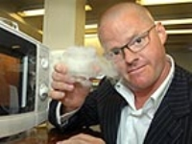
British culinary alchemist Heston Blumenthal turns his attention to the biggest meal of the year - Christmas dinner. He is making a Christmas feast for six celebrity guests.

This one-hour special is not going to be one of those Christmas cookery programs that lead to a rush on cranberries. This is hardcore Heston. This is his idea of what the Christmas dinner should be. Heston pushes the boundaries of multisensory cooking to the limit, taking inspiration from the past, present and future of Christmas.

Cooking for six special guests who all have one thing in common, a genuine love of food, Heston’s aim is to make them feel like children again albeit with some very sophisticated tastes. Guests Terry Wogan, Kirsty Wark, Dara O’Briain, Rob Brydon, Richard E. Grant and Sue Perkins have no idea what to expect.

Sourcing ingredients from Oman, Paris and Siberia, Heston treats his guests to a spectacular Christmas dinner like no other. And not one he would recommend you attempt to make at home!

 http://abc.net.au/iview/
PRODUCTION DETAILS:
Heston Blumenthal’s Perfect Christmas is produced by Fremantle media for BBC2. Executive producer: Gary Hunter.

Sunday
7:30pm

The Whitlams And The Sydney Symphony Orchestra
Sunday, 12 December 2010

The boys are back by popular demand to perform with the Sydney Symphony!

After four sell-out shows with the Sydney Symphony Orchestra in 2007, ARIA award-winning band The Whitlams returned to the Sydney Opera House to again make magic with the Sydney Symphony.

Celebrating the 12th anniversary of their quadruple platinum, ARIA breakthrough album, Eternal Nightcap, the band and the Orchestra will play the album in its entirety. Featuring all their best-selling hits from No Aphrodisiac to Charlie No. 2 and You Sound Like Louis Burdett, expect a program of soulful and heart-warming music.

Lead singer and pianist Tim Freedman’s collaboration with classical musicians began in 2004 when he was approached by the Western Australia Symphony Orchestra to perform a set of shows with them. Since then, The Whitlams have played with orchestras including the Australian Chamber Orchestra and the Sydney Symphony.

The Whitlams formed in Newtown Sydney in 1992 and began by playing at the Sandringham Hotel in King Street. The following year they travelled to Byron Bay and Brisbane every six weeks in an old Kingswood station wagon – taking turns lying on the piano in the back – to become a ‘real band’. This year also saw the release of their first album Introducing The Whitlams.

In 1998, the band won an ARIA for Song of the Year and Best Independent Release for their 3rd album, Eternal Nightcap. These special concerts with the Sydney Symphony celebrate the album’s success. The current line-up has remained unchanged for the last seven years and four albums, and consists of Tim Freedman (piano and vocals), Jak Housden (guitar), Warwick Hornby (bass guitar) and Terepai Richmond (drums).

http://abc.net.au/iview/

Thursday
8:30pm

School Of Comedy
Thursday, 16 December 2010 Final
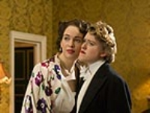
What started as a school drama project and found its way to the Edinburgh Fringe returns with a swag of hilarious adult characters parodied in a series of short skits by up-and coming child performers.

The child’s eye view is startling in its bold mockery of characters such as the 1930s twee upper-class couple the wife of whom is a lesbian; flippant paramedics who can’t stop laughing when things are most dire; a jokester at an AA meeting, and transplant organ couriers with a bent for shouting at people through their van window.

There’s also a great take on people who don’t respect personal boundaries.

Bad language, great talent, singing and dancing!

http://abc.net.au/iview/
PRODUCTION DETAILS:
Produced and devised by Laura Lawson; Executive Producer: Andy Harries for Left Bank Pictures.

Friday
8:00pm

Rude Boy Food
Friday, 17 December 2010

Rebel chef Aaron Craze cooks American street food for the hens night for his friend Sarah.

The wedding is in New York, so he treats her and her girlfriends to hot dog canapés, crab cakes, New York strip steak cooked on hot marble plus banana and pecan cupcakes.

The girls’ party is a hit and there’s hardly a crumb left.

http://abc.net.au/iview/
PRODUCTION DETAILS:
Executive producers: Catherine Catton and Zoe Collins; Producer: Alex Lind; Fresh One production for UKTV.

Friday
8:30pm

The White Stripes: Under Great White Northern Lights
Friday, 17 December 2010
Filmmaker Emmett Malloy followed the rock band White Stripes through their Canadian tour, culminating in their 10th anniversary concert in Nova Scotia.

Jack and Meg White’s gigs included not only the usual venues, but also buses, cafes and before Indian tribal elders.

Malloy captures this special tour, including the extraordinary concert versions of the band’s minimalist, raw, blues-inspired rock songs and the special relationship between the two. Jack, the extrovert and the introspective Meg were formerly married, but for a long time they claimed to be siblings.

A captivating mix of striking live footage and poignant off-stage moments, the film brings the band full circle to a place reminiscent of how they started – shows where no one knew who they were and their music had to make the first impression.

http://abc.net.au/iview/
PRODUCTION DETAILS:
Directed by Emmett Malloy.

Saturday
7:45pm

Republic Of Doyle
Saturday, 18 December 2010
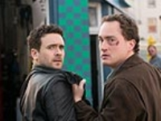
Standing at his mother’s grave, Jake receives an earful from Mal about getting into trouble because of the women he’s involved with - just as they see a distraught and beautiful woman, ‘Annabelle’ (Kathleen Munroe), stumbling through the cemetery alone.

With bloody evidence of a head injury and no memory of anything since, including who she is, Annabelle relies on the kindness of the Doyles to help her find... herself. But Mal steps aside and leaves this one to Jake, distrustful of Annabelle’s story and distracted by the chaos in his personal life. As Jake pulls the pieces of the case together, he starts to fall for Annabelle despite Mal’s warnings and despite the fact that Annabelle turns out to have a shady past.

Annabelle is being hunted by two creepy looking men who try to force her to leave with them. Just when things couldn’t get any more tangled, it turns out that Annabelle is married to 78-year-old wealthy lawyer, Eli Kent (Eric Peterson). Jake forces the truth from all the players and it’s a revelation to all, especially to ‘Annabelle’, who has yet to regain her memory.

Meanwhile, Mal struggles with Rose’s volatile marital situation and is further shocked when cop buddy Reece (Chuck Herriot) uncovers that not only was Martin involved in drug trafficking back in the day - so was Mal’s darling Rose. And despite their fiery fling, Leslie gives Jake the cold shoulder in an attempt to break their personal ties before he breaks her heart.

http://abc.net.au/iview/
PRODUCTION DETAILS:
Episode 7 is written by Jeremy Boxen and directed by Robert Lieberman. Republic Of Doyle is created by Allan Hawco, Perry Chafe and Malcolm MacRury. Executive Producers: Allan Hawco, John Vatcher and Michael A. Levine. Produced in association with the Canadian Broadcasting Corporation (CBC).

Watch Out For…
Monday, 13 December 2010
10:00pm

Glastonbury 2010: Stevie Wonder
This annual festival, now in its 40th year, has the power to attract some of the biggest names in the music industry, across the full spectrum of musical genres.
Headline acts in 2010 include Muse, Stevie Wonder and Gorillaz, Snoop Dogg, Jack Johnson, Norah Jones, Jackson Browne, Pet Shop Boys, Willie Nelson, Kylie Minogue, Scissor Sisters and Shakira.
Glastonbury Festival is the largest and most revered open air music and performing arts festival in the world.
Basking in glorious sunshine 177,000 revellers enjoyed a feast of musical performances from some of the biggest names in the business.
The festival also provides a breeding ground for special moments and collaborations.
There are few other places you can see duets between Kylie and the Scissor Sisters, Snoop Dogg and Damon Albarn and the likes of De La Soul and Bobby Womack sharing a stage.
http://abc.net.au/iview/

Thursday, 16 December 2010
9:30pm

The Graham Norton Show
Graham Norton is back with yet another series of his inimitable chat show. Each week Graham presents a show focusing on the people, trends, stories and aspects of celebrity culture that interest him most, featuring trademark Norton comedy monologues and celebrity chat.
This week’s guests include comedian and actor Jack Black, comedian Miranda Hart and pop star Justin Bieber.

Saturday, 18 December 2010
8:30pm

It's A Wonderful Life
As a boy, George Bailey dreamed of travelling the world and seeing all the mysterious, exotic places far beyond his quaint little hometown of Bedford Falls. As a young man, George plans to fulfil his dream in spite of his father’s quest that he joins the Bailey Savings and Loan Company, the family business and the only institution protecting the townspeople from Henry Potter, a greedy banker.
Before he can put his plan into practice, however, his father dies, and George is faced with a difficult choice – either take his father’s place or stand by as the ruthless Potter dissolves the firm. Unable to leave his town’s fate in Potter’s hands, George chooses to forego his dream and assume leadership of the Savings and Loan Company.
Later, George gives up his dream for good when he falls in love with and marries his childhood sweetheart, Mary. Even his honeymoon plans dissolve when George’s savings must go to pay off his company’s investors during the famous bank run of 1932.
Over the next few years the Savings and Loan company flourishes and George and Mary raise a family. Then, one day, George’s Uncle Bill misplaces a bank deposit on the very day the bank examiner arrives to check the company books.
Faced with ruin, George is driven to despair and rashly wishes that he might never have been born. Clarence, an Angel Second Class sent down from Heaven, grants his wish and shows George how his town would have fared if he had never existed.
Directed by Frank Capra, It’s A Wonderful Life stars James Stewart, Donna Reed, Lionel Barrymore, Thomas Mitchell and Henry Travers.

