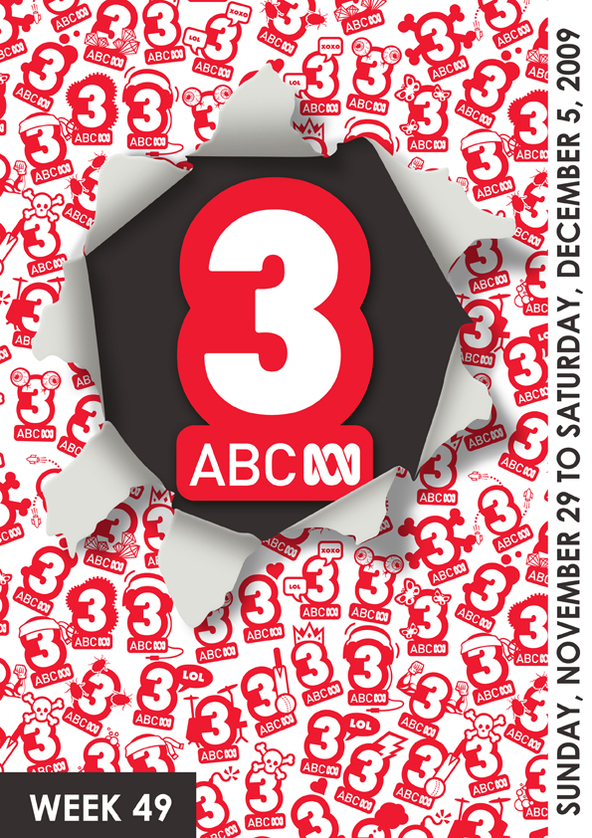
Index
Program Highlights 1
Prank Patrol 1
CJ The DJ 2
Richard Hammond's Blast Lab 3
My Place 4
Watch Out For… 5
Rush TV 5
Program Guide 6
Friday, 4 December 2009 6
Saturday, 5 December 2009 7
Marketing Contacts 11

Program Highlights
Friday
6:00pm

Prank Patrol
Friday, 4 December 2009 New Series
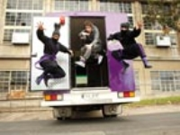
In this hilarious series, Aussie kids get to create, build and execute a big time prank! All they have to do is call in the…..PRANK PATROL!

In each episode, host Scotty Tweedie, the customized Spy Van and the two prank-loving Ninjas will help pull off the prank of a lifetime. Scotty will meet a new prankster in each episode who is on a mission to prank someone they know, whether it be a friend, sibling, parent or teacher.

While they’re busy building their dream prank, each episode will feature Ninjas On The Loose- a segment where Ninjas take their cheeky pranks to fool the unsuspecting public. Then there is also the Recipe for a Prank animation, showing viewers simple pranks they can pull off at home.

It all builds up to the ‘gotcha’ moment...can our prankster pull it off? Fun and mayhem is guaranteed and the reactions from the ‘pranked’ make it all worthwhile!

Episode 1: Superglove - Begins December 4 at the special time of 6pm

Today Mitchell joins the Prank Patrol. His mission: to fool his friends into thinking he’s made a high tech glove so powerful – it’s explosive! With the help of Scotty and the Prank Patrol Ninjas, Mitchell meets the experts who can help him pull off the prank of a lifetime. First stop is an Internet Guru who shows him how to create a bogus website all in the name of fooling Mitchell’s friends. Next stop is the special FX studio where the team help him set up a series of awesome air compression explosions. Last stop...the scene of the prank!

Please note: after December 4, Prank Patrol will screen Monday-Saturday at 6.30pm on ABC3
PRODUCTION DETAILS:
activeTV

Friday
6:30pm

CJ The DJ
Friday, 4 December 2009 New Series
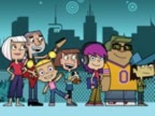
At thirteen, CJ (voiced by Holly Brisley) is already a hot DJ - the only trouble is most of her gigs are in her own bedroom. She can spin discs like no-one else, mix and scratch tracks like a pro - but in the deader than dead end of town where she lives, almost nobody wants to know. CJ has a passion – to play her music to the world.

CJ’s best friends are talented, hip-hop jazz musician Si and logical Lesley who prefers hitting the books to dance parties.

Episode 1: Set Up Gig – Friday December 4 at 6:30pm on ABC3

It’s party time – CJ gets a call from Arnis about a gig for an older audience. CJ takes the gig despite Lesley’s rumour that party guy Zack might be throwing a party the same night. Arriving at the ‘big’ party, CJ discovers Arnis has tricked her… the party is for Arnis’s grandmother Esme’s birthday. Plus Zack has just called – he wants her to play at his party. What will CJ do?

Episode 2: Ring Ring – Saturday December 5 at 6:20pm on ABC3

CJ, Si and Lesley are all shocked when they go to check out the new Rough Cut fashion store. Lesley is appalled that the Lucky Puppy Pet Store has closed down to make way for the new store and CJ can’t believe the hideous in-store music playing, so she leaves her demo pretending it belongs to her much older sister, AJ.
PRODUCTION DETAILS:
Kapow Pictures Australia with Vision Animation Malaysia for ABC TV

Friday
7:05pm

Richard Hammond's Blast Lab
Friday, 4 December 2009 New Series
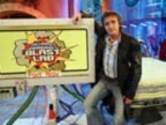
Richard Hammond's Blast Lab is an entertaining and educational studio-based science game show set in the surreal world of Richard's secret laboratory, found under the watermill of his fictitious country mansion. Richard is assisted by the Lab Rats, along with Ninja Nan, a 70-year-old lady in charge of security and Mini Miss, Richard’s old science teacher from school, who is on hand to help with the experiments in the studio and the lab. This 52-part half-hour series is jam-packed with the most spectacular stunts and awesome experiments you are likely to see this year.

Two teams of three contestants compete with each other to win fantastic prizes by battling it out over four rounds.

Whilst the winning team walks away with a number of cool prizes, the losing team must blow up their prizes in an exploding bidet. Nothing is ever quite as it seems in this exciting, surreal and action-packed show.

Episode One: Friday December 04 at 7:05pm

The theme for the debut episode is ‘Rocket Propulsion’, with the Red Team ‘The Invincible Terrible Trio’ going head to head with ‘The Nuclear Boys’, otherwise known as The Yellow Team. Battling against each other, the teams play the true or false game ‘Oliver’s Fact Lab’, learn about the great Sir Isaac Newton in ‘Balloon Rocket Rescue’ while today’s Messy Messy Mess Test is ‘Gungee Bungee’.

Episode Two: Monday December 0 at, 7:05pm

Themed ‘The Weight of Liquids’ this episode is a battle of the sexes with the all boys team from Northern Ireland ‘The Bin Lids’ (The Red Team) sizing up against the all girls team ‘Hammy’s Heroes’, from Bolton, England (The Yellow Team). Today’s Messy Messy Mess test is ‘The Bridge of Destiny’... as scary in real life as it sounds, while the Mini Science Experiment finds Ninja Nan and Richard putting their weight to the test.
PRODUCTION DETAILS:
A September Films production

Friday
8:00pm

My Place
Friday, 4 December 2009 New Series

The new ABC TV drama series My Place tells the story of the children who live in the very same spot in Australia over 130 years. Opening in 2008 and taking us back to 1888, the series introduces us to 13 kids, all with a talent for some kind of trouble, each hiding up the same old fig tree and each with a story to tell.

The series is based on the acclaimed, multi-award winning children’s book written by Nadia Wheatley and Donna Rawlins in 1988. It is also accompanied by a rich website in which kids and their families can explore the world of the My Place kids and have fun with the history of each decade.

My Place – the series, the website and the book – is a rare kids’ story of Australia.

Episode One: Friday December 4 at 8:00pm

We meet 10-year-old Laura. She borrows a tinnie to muck about in the canal. It sinks, taking with it the ashes of its owner’s beloved dog. She can’t find a way to own up and say sorry. It’s 2008 and the Prime Minister is trying to do the same thing with her mob.
PRODUCTION DETAILS:
Produced by Penny Chapman and Co-produced by Helen Panckhurst for Matchbox Pictures. Executive Producers Carla de Jong and Bernadette O’Mahony. Episode 1 written by Leah Purcell, and directed by Shawn Seet.

Watch Out For…
Saturday, 5 December 2009
7:00pm

Rush TV
Rush TV takes an insightful look into the incredible world of action sports and the personalities that are found within. The series shows a full range of action packed sequences from Australian and international athletes.
Hannah Wang will report on various sporting events, explore the fusion between sport and music, fashion and the arts and show how the culture of action sports has become a full time and viable way of life. Be inspired and entertained as the athletes share their tips, favourite locations and inside information. The show also serves as a credible platform for showcasing the latest in action sports content.

Program Guide
Indicates the prime time programs

Friday, 4 December 2009
6:00 | Prank Patrol  (CC)  Host Scotty Tweedie and the two Prank Patrol Ninjas help pull off the prank of a lifetime. Scotty meets a new prankster in each episode who is on a mission to prank someone they know.
6:30 | CJ The DJ: Set Up Gig  (CC)  At thirteen, CJ is already a hot DJ- the only trouble is most of her gigs are in her own bedroom. She can spin discs like no-one else - but in the deader than dead end of town where she lives, almost nobody wants to know.
6:55 | News On 3  An action-packed bulletin, featuring the top news stories and issues of the day hosted by Nathan Bazley.
7:05 | Richard Hammond's Blast Lab  (CC)  An entertaining and educational science game show jam-packed with the most spectacular stunts and awesome experiments on television. Two teams compete with each other to win prizes by battling it out over four rounds.
7:35 | Jeopardy  (CC, Repeat, G)  UFO-mad Scottish students are eager to find out what really happened to a couple who claimed to have been abducted by aliens in the Blue Mountains. The mystery deepens when the students themselves vanish.
8:00 | My Place  (CC)  Adapted from the award-winning children's book of the same name, comes a story of the children who live in the very same spot in Australia over 130 years.
8:30 | Heartbreak High  (CC, G)  A drama series based on the lives of a group of students who attend the fictional Hartley High School in Sydney.

Saturday, 5 December 2009
6:00 | Class Of The Titans: Chaos 101: Part One  (CC, Repeat, G)  Seven teenagers have been summoned to Century City for some very important business - saving the world! What's so special about these teens? They are direct descendants of seven of the greatest heroes ever!
6:20 | Dragon Booster: The Choosing: Part 1  (CC, Repeat, G)  Avid game designer Artha Penn has no interest in racing real dragons until a legendary black and gold dragon named Beau chooses him to be the Dragon Booster.
6:45 | Skyland: Dawn Of A New Day: Part 1  (CC, Repeat, G)  In a future where Earth had been shattered into millions of pieces and water has become the issue of all powers, Mahad looks for his sister. His quest takes him to discover new civilisations and amazing places where freedom still reigns.
7:10 | Wolverine And The X-Men: Hindsight : Part 1  (CC, Repeat, G)  An animated series centred around the most popular of the X-Men, Wolverine, as he and his super-power endowed brethren battle to save the plant from oblivion.
7:35 | Countdown To 3  (CC, Repeat)  Want to know what all the fuss is about? Join the hosts of ABC3, as well as Cassie Davis, Short Stack and Prime Minister Kevin Rudd as they countdown to the launch of ABC3.
8:35 | Prank Patrol  (CC, Repeat)  Host Scotty Tweedie and the two Prank Patrol Ninjas help pull off the prank of a lifetime. Scotty meets a new prankster in each episode who is on a mission to prank someone they know.
9:00 | Richard Hammond's Blast Lab  (CC, Repeat)  An entertaining and educational science game show jam-packed with the most spectacular stunts and awesome experiments on television. Two teams compete with each other to win prizes by battling it out over four rounds.
9:30 | Best Of RollerCoaster
Best Ed: Paws For Alarm
(CC, Repeat, G)
The kitten twins get a bit carried away while playing with Ed.
Best Ed: Send In The Klownmans
(CC, Repeat, G)
New neighbours move onto Sweet Street.
Carl Squared: The Art Of Being Carl
(CC, Repeat, G)
Being a teenager is tough- try being two! That's the dilemma facing Carl Crashman, a slacker teen who accidentally creates his own clone after venting about his life online.
10:30 | Spliced!  (G)  What do cow-pig-shrimp-chickens, robots with beautiful hair and two-legged rhinos have in common? Nothing. But they're all in Spliced a show about mixed-up freaky animal mutants and their mixed-up freaky animal mutant friends.
10:55 | Grossology: Sinister Rivalry  (CC, Repeat, G)  When downtown becomes the site of an epic bug battle it's time for Ty and Abby to take down Insectiva and her hated twin sister Arachnidia.
11:20 | Grossology: Flushed Away  (CC, Repeat, G)  When alligators start showing up in people's toilets it's obvious something fishy is going on in the sewers.
11:45 | Jeopardy  (CC, Repeat, G)  UFO-mad Scottish students are eager to find out what really happened to a couple who claimed to have been abducted by aliens in the Blue Mountains. The mystery deepens when the students themselves vanish.
Jeopardy
(CC, Repeat, G)
Sarah tells the group about her encounter with a UFO. The others do not believe her, so Sarah attempts to prove it by showing them a video of the encounter.
Jeopardy
(CC, Repeat, G)
Leon is injured so Melissa decides to go back to the jeep alone. David and Harry go off to find leeches to suck out the poison in Leon's blood.
Jeopardy
(CC, Repeat, G)
David is upset to discover that Harry has stopped taking his medicine for his epilepsy.
Jeopardy
(CC, Repeat, G)
Gerry begins to worry when Melissa does not return and decides they need to carry Leon back themselves.
1:55 | Old Tom: Lost And Found  (CC, Repeat, G)  The adventures of the prim and proper Angela Throgmorton and her good-natured but slothful cat, Old Tom. Angela is obsessive about good manners but Old Tom is a practical joker who disrupts her harmony and order.
2:10 | Flipper And Lopaka  (CC)  An animated series about Flipper the dolphin, Lopaka, a young Polynesian boy and their appealing gang of aquatic friends. Flipper and Lopaka combine resources to triumph over an evil giant octopus.
2:35 | Yakkity Yak: Hypnotic Yak/ As The Worm Turns  (CC, Repeat, G)  High school class clown Yakkity Yak strives to shine as the next comic superstar, despite his total lack of comedic talent.
3:00 | Worst Best Friends  (CC)  On a school excursion to the Sparkling Star Bottle works, Millicent and Dusting become trapped and are convinced that aliens have abducted Thesaurus.
3:30 | Countdown To 3  (CC, Repeat)  Want to know what all the fuss is about? Join the hosts of ABC3, as well as Cassie Davis, Short Stack and Prime Minister Kevin Rudd as they countdown to the launch of ABC3.
4:30 | Barney's Barrier Reef: Conmen  (CC)  Dive into the incredible world of Australia's Great Barrier Reef, as Barney discovers creatures that are quirky, crazy and creepy!
5:00 | Richard Hammond's Blast Lab  (CC, Repeat)  An entertaining and educational science game show jam-packed with the most spectacular stunts and awesome experiments on television. Two teams compete with each other to win prizes by battling it out over four rounds.
5:30 | Super Hero Squad  (CC)  The universe is at stake as the infinity Sword is shattered in a battle between Iron Man and Dr Doom. Iron Man puts together the only team capable of gathering the Sword's pieces and beating Doom - the Super Hero Squad!
5:55 | Shaun The Sheep: Double Trouble  (CC)  A bored Shaun dresses up as the Farmer to entertain the flock. Realising he now has the power to boss Bitzer around, Shaun takes the opportunity to throw a bit of a party for the flock.
6:05 | Jibber Jabber: Night Of The Vampire  (CC, Repeat, G)  Sir Duke of Jib and Jabbury must triumph over Jessula before she turns the household into vampires. When ghosts terrorise Jib Jab Manor, Sir Duke of Jib and Jabbury is on the case.
6:20 | CJ The DJ: Ring Ring  (CC)  CJ, Si and Lesley check out the new Rough Cut fashion store. Lesley is outraged that the store has taken the place of the former Lucky Puppy Pet Store, while CJ is horrified by the awful instore music.
6:30 | Prank Patrol  (CC, Repeat)  Host Scotty Tweedie and the two Prank Patrol Ninjas help pull off the prank of a lifetime. Scotty meets a new prankster in each episode who is on a mission to prank someone they know.
7:00 | Rush TV  (CC)  An insightful series that looks at the incredible world of action sports. Be inspired and entertained as the athletes share their tips and inside information with Hannah Wang.
7:30 | Iron Man: Armored Adventures: Iron Forged In Fire: Part 1  (CC, Repeat, G)  Teen genius Tony Stark has just finished his greatest invention: the Iron Man armor. But before he gets to show his dad, Tony's world is shattered.
7:50 | Iron Man: Armored Adventures: Iron Forged In Fire: Part 2  (CC, Repeat, G)  Obadiah Stane has taken over Stark International and is converting all of Tony and his dad's inventions into weapons. But even worse, Tony now believes Stane may be behind the attack that took his father from him.
8:15 | Iron Man: Armored Adventures: Cold War  (CC, Repeat, G)  Iron Man is still trying to take down Obadiah Stane when he finds someone else is after Stane, the man called Blizzard.
8:35 | Iron Man: Armored Adventures: Secrets And Lies  (CC, Repeat, G)  The Mandarin believes Tony Stark can find the missing Makluan Rings, so he plans to get close to him in his true identity, sixteen-year-old Gene Khan.

