
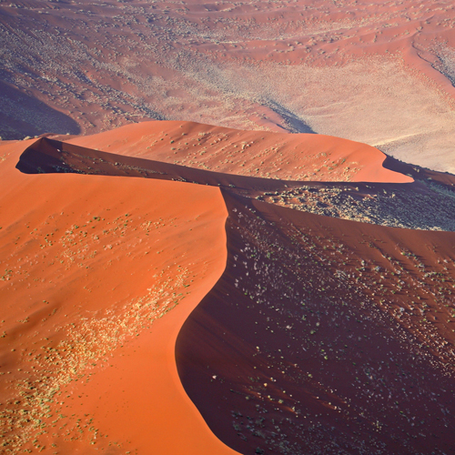

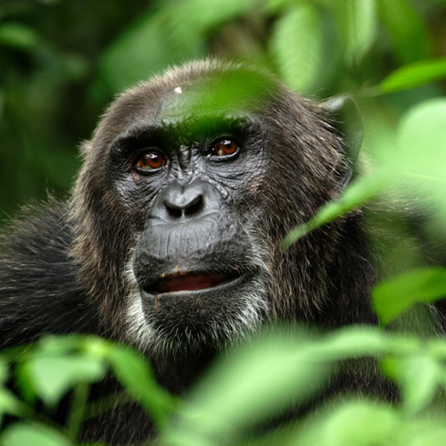
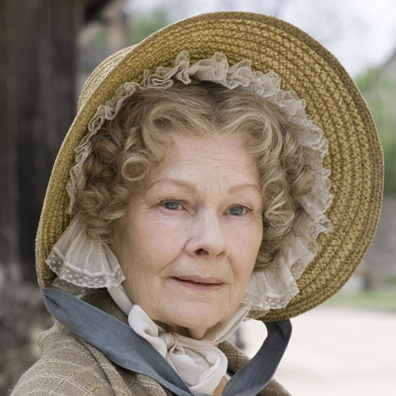

DECEMBER 2008 PROGRAMMING HIGHLIGHTS Entertainment I Documentaries I Music & Arts

KING LEAR
AUSTRALIAN PREMIERE
Wednesday December 24 at 8:30pm, concludes Thursday December 25 at 8:30pm

The Royal Shakespeare Company’s recent production of King Lear is immortalized in stunning high definition at the famed Pinewood Studios. Specialists in stage-to-screen adaptations, The Performance Company filmed over a two week period followed the conclusion of a very successful tour. Retaining most of the original cast including the incredible Sir Ian McKellan in the title role, this performance will be enjoyed by lovers of theatre and those new to the medium.

THE LIFE AND TIMES OF VIVIENNE VYLE
CHANNEL PREMIERE
Starts Thursday December 11 at 8:30pm

MOVE OVER TRISHA…..THERE IS A NEW TALK SHOW QUEEN IN TOWN!

It's Ab Fab meets The Larry Sanders Show with quite a bit of Ricki Lake and Oprah thrown in for good measure. 'The Vivienne Vyle Show' is Britain's most loved, most watched and most talked about talk show. Vivienne Vyle is the show's host and she will do anything to maintain her celebrity status - her brand. She is not afraid to say exactly what she thinks and offer her own unique, frank advice. According to Vivienne, the only way to solve a problem is through honesty and openness. To this end she takes her guests - the mentally unwell, depressed, terminally ill (or just terminally stupid) - and, if necessary, screams at them. Jam packed with confessions and scandalous revelations, every day before a live audience, Vivienne addresses the big issues such as: “My Son calls the wrong man Daddy” and I want a vagina but cant kick the crack’.

In the Studio Vivienne is aided by her manic produce Helena (Miranda Richardson), who actively encourages on air punch ups and rows to boost the ratings. As ratings soar Vivienne’s ego begins to expand in line with her audience figures. But behind the successful façade of sharp suites and straight talking honesty, Vivienne is struggling with her own private life. She ponders what to do with the frozen vile of her dead husbands sperm but at 47 she is probably too old to have a child, her new marriage is a sham and she is not sure what she wants anymore. How can she be expected to advise other people when her own life is in a state of flux? A look at the real Vivienne reveals her vulnerability, insecurity and her obsession with ratings.

Can Vivienne take her own therapy and just sort out her life?

Stars: Jennifer Sunders (Absolutely Fabulous and French and Saunders) and Miranda Richardson (Harry Potter and the Goblet of Fire and BlackAdder).

SENSITIVE SKIN
CHANNEL PREMIERE
Starts Thursday December 11 at 9:00pm
Meet Al and Davina Jackson. He’s a pundit for a broadsheet newspaper, paid to find imperfection in everything. She works in an art gallery and is paid to make life more beautiful.
Life around 60 isn’t simple; their 30-year-old son Orlando refuses to acknowledge adulthood while Davina’s sister Veronica and her husband Roger intimidate the Jacksons with their confident and controlled grasp of life.
A dark comedy that looks at life through the eyes of a successful couple living in metropolitan London. Along with their friends they struggle with sexual temptation, professional jealously and cope with their fear of the future.

Stars: Joanna Lumley (Absolutely Fabulous, Jam and Jerusalem), Denis Lawson (Holby City, Bleak House), James Lance (Absolute Power, Teachers), Maggie Steed (Born and Bred)

DIANA: LAST DAYS OF A PRINCESS
CHANNEL PREMIERE
Wednesday December 17 at 7:30pm
The final days of the world's most famous woman.
It is August 1997 and Princess Diana is once more dominating headlines. Embracing romance and basking in luxury, her jet-set lifestyle is the stuff of fantasy. One year after her divorce with Prince Charles, she has cast aside her official protection officers and is provoking anger with her campaign against landmines.

Diana is living life to the full, amid the constant glare of publicity, in the company of Dodi Al Fayed, son of international business tycoon Mohammed Al Fayed. Accompanying the lovers from the palm trees of Saint Tropez to the sparkling streets of Paris, this powerful and emotive film reveals the key moments leading up to their death. As Diana seeks an elusive sense of freedom, and the photographers chase the promise of instant riches, discover exactly how events on the night of August 31, 1997 tragically spiralled out of control. Ten years after the fatal crash that stunned the world, interviews and compelling full-scale drama capture the final days of one of the 20th Century's greatest icons.

TOP GEAR POLAR SPECIAL
CHANNEL PREMIERE
Wednesday December 17 at 9:30pm

It’s the ultimate test of man against machine – or should that be dog against machine – as the Top Gear team set out on their most ambitious and arduous challenge to date.

Jeremy Clarkson, James May and Richard Hammond take part in a Polar Special. It is an epic land race starting in the town of Resolute, Northern Canada finishing 450 miles later at the Magnetic North Pole.
The terrain they tackle is some of the toughest on Earth – a mix of mountainous land masses and jagged sea ice where temperatures can drop to a mind-numbing minus 65 degrees Celsius. And then there are the polar bears. The Arctic is home to 80 per cent of the world’s polar bear population and, when it comes to lunch, they really don’t care if it’s seal or human.

This being Top Gear, the three presenters’ modes of transport are a little out of the ordinary. Jeremy and
James, of course, drive. Their vehicle of choice has been specially converted for the task by an Icelandic engineering team whose achievements include the first crossing of the Greenland Ice Cap by car.
Richard travels on something a little less hi-tech – a sled pulled by a team of 10 Canadian Inuit dogs.
Richard’s human companion is Matty McNair, a hugely experienced Polar explorer who has an almost telepathic understanding of her dogs.

Pitting dog power against horse power may sound like a one-sided contest but, given the nature of the terrain, there’s no telling who will make it to the pole first. In fact, there’s no guarantee that either team will make it to the finish line at all…

HOTEL BABYLON – series 2
CHANNEL PREMIERE
Starts Sunday December 21 at 9:30pm

Check in for more indulgence, decadence and debauchery as Tamzin Outhwaite and Max Beesley return for the second series of Hotel Babylon. With guests such as Jerry Hall as glittering as the Hotel's chandeliers, General Manager Rebecca is determined to run a tight ship. But work has taken its toll on her private life and this series finds her in the middle of a divorce and at times losing sight of her friends. When faced with romance at work, will Rebecca practise what she preaches to her staff? Meanwhile, Charlie finds his patience tested on many occasions and, when faced with a family dilemma, he sails too close to the wind and risks landing himself back in jail. And Head Concierge Tony gains a new trainee Luke - with his good looks, confidence and naughty streak, he promises to turn heads both back and front of house.

Inspired by Imogen Edwards-Jones' searing expose of life behind the scenes of the luxury hotel industry in London, Hotel Babylon takes us on a journey beyond the glamour and facade of the smiling faces and glittering chandeliers and into the frenetic, non-stop world of the staff.

Stars: Max Beesley (Bodies and Talk To Me), Tamzin Outhwaite (Red Cap and EastEnders), Dexter Fletcher (Band of Brothers and Topsy Turvy), Emma Pierson (Charles II and Talk to Me).

