
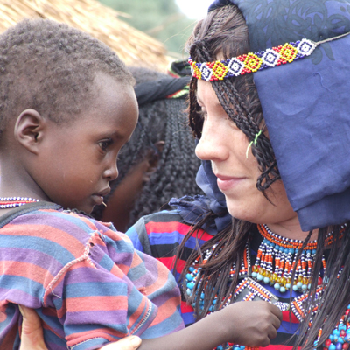

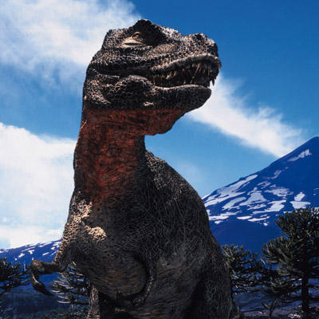
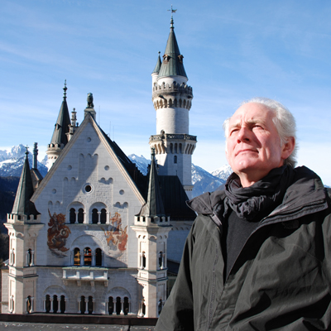

DECEMBER HIGHLIGHTS 2008 Entertaining Brains

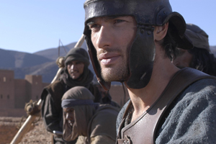
ANCIENT ROME: RISE AND FALL OF AN EMPIRE (6 x 60)
AUSTRALIAN PREMIERE
Starts Saturday November 29 at 8:30pm

Combining CGI with spectacular live action battles, this dramatised documentary series tells the true story of ancient Rome through the six crucial moments that helped shape the destiny of the Empire. This is the story of some of the most powerful rulers in history – a story of greed, lust, decadence and bloody ambition.

Starting in 146 BC, the series begins with Rome finally destroying its ancient enemy Carthage; leading to the celebrated victory of Julius Caesar and the overthrow of the Republic; the dramatic story of how Emperor Nero descended into madness; the story of the biggest rebellion in Imperial history – the Jewish Revolt; how Constantine brought Christianity to the Empire; and finally the downfall of Rome, told through the tale of Alaric the Goth.

Factually accurate and based on extensive historical research, this revealing series portrays Roman life as it really was: gritty, sordid and magnificent. Never before has the true story of Rome been presented with such dramatic reality. CGI is mixed with compelling drama, a stunning cast and spectacular live-action battles to create the definitive television history of how the Empire was formed, how it achieved maximum power, and why it eventually failed.

These six engrossing tales come together to tell one epic story – the real story of the Roman Empire.

Stars: Sean Pertwee (Julius Caesar, Cold Feet), John Shrapnel (Troy, Gladiator), Peter Firth (Spooks, Pearl Harbor), James D’Arcy (Master & Commander) and Geraldine James (State of Play, Little Britain)

Additional information is available.
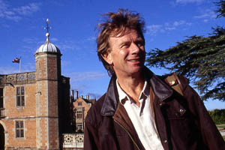
IN SEARCH OF SHAKESPEARE (4 X 60)
CHANNEL PREMIERE
Starts Monday December 1 at 8:30pm

Michael Wood presents an innovative and revealing portrait of the world's greatest and most famous writer, William Shakespeare. This intriguing documentary mixes travel, adventure, interviews and specially shot documentary-style and live action sequences of current Royal Shakespeare Company players to explore the mystery of the man himself and examine the complex society in which he created some of literature's most enduring characters.

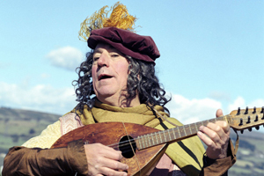
TERRY JONES MEDIEVAL LIVES (8 x 30)
AUSTRALIAN PREMIERE
Monday December 1, at 9:30pm

As well as being part of a groundbreaking comedy team Monty Python, Terry Jones is also a respected medieval scholar. Here, he throws aside tired old clichés to investigate what really went on in the Middle Ages. Discover how two senior citizens saved England for the young King Henry III, how abbots had armies and how bishops ran brothels.

Each episode explores the real role and function of eight medieval archetypes:
The Peasant - Weren’t medieval peasants miserable, dirty, poor and ignorant? In fact the politicised working class as depicted by The Holy Grail was not very far from the truth.
The Monk - A life of prayer in peaceful service to God? Not for many medieval monks, who devoted their lives to making lots and lots of money.
The Damsel - It wasn’t unknown for a damsel to abduct a knight – others had their own businesses, some even ran armies.
The Minstrel - In the Middle Ages, entertainment was a risky business. Not only was medieval showbiz a precarious career, but minstrels often found themselves involved in wars and politics.
The Knight - Hero in shining armour or murdering, looting rapist? Discover some unsavoury truths – and the dark side of chivalry.
The Philosopher - The reputation of medieval scientists, known then as philosophers, has been unfairly blackened. They understood a lot more than we give them credit for.
The Outlaw - Outlaws were often members of the gentry, but unlike the legendary Robin Hood they robbed the poor to give to the rich.
The King - Can we really be sure who the medieval kings actually were? Terry Jones uncovers evidence of a King Louis, who seems to have been airbrushed from history.


TOP GEAR
CHANNEL PREMIERE
Every Friday at 7:30pm
You know it. You love it. It’s on every week. Don’t miss it.

Top Gear is quite simply the world's biggest motoring media brand. Multi-award-winning and attracting a global audience of over 500 million, Top Gear takes the public's passion for cars, strips away the boring stats, adds enthusiasm, thrilling stunts and challenges to deliver a shot that is accessible to a broader audience (over 40% of viewers are female). Most of all, Top Gear is about having fun and being able to feel part of the best gang in the world.

The relationship of the presenters – Jeremy Clarkson, Richard Hammond and James May– is key to the format’s winning blend of honesty, passion and downright stupidity. The fast-paced banter and the ludicrous situations in which they find themselves are something you could never script or synthesize in a producer’s office. This giggling gang of grown men who sometimes should know better are the real deal – actual mates, who just can’t believe their luck that they can spend all day messing around together and call it a job.

And it shows. Here, cars are just the starting point for epic road trips, over-ambitious projects (an electrical fire inside a car wash, anyone?), and lashings of good old-fashioned mucking about by presenters and celebrities who really should know better. Get into it!

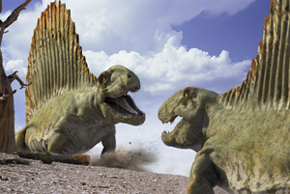
WALKING WITH MONSTERS (3 x 30)
AUSTRALIAN PREMIERE
Starts Monday December 8 at 7:30pm

From the makers of Walking With Dinosaurs and Walking With Beasts comes an epic and entertaining new exploration of life, revealing that in the age before dinosaurs, a succession of fantastical animals and plants ruled the planet. Most of us are completely unaware that these creatures ever existed, or believe our planet was home to just worms and bugs. Yet there was a time when a two-tonne predatory fish came on land to hunt, when four-metre sea scorpions sliced sushi in the shallows, when just one species of lumbering reptile represented eighty per cent of all life. For the first time, this series uncovers these creatures and the bizarre worlds they inhabited.

Additional information is available.
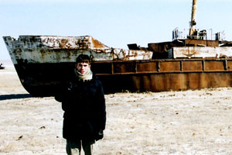
HOLIDAYS IN THE DANGERZONE: MEET THE STANS
AUSTRALIAN PREMIERE
Sunday December 14, at 8:30pm
…that’s Kazakhstan, Kyrgyzstan, Tajikistan and Uzbekistan

Kazakhstan, Uzbekistan, Tajikistan and Kyrgyzstan were part of the Soviet Union until it collapsed in 1991.Twelve years later, these four ‘stans’, which cover an area of land bigger than Europe, are ruled by despotic leaders who have failed their people.
The West has long ignored Central Asia. But in the aftermath of September 11th, the United States has begun establishing military bases in the region, to combat the threat of terrorism. The region (and this is
perhaps no coincidence!) has the largest untapped oil and gas reserves in the world.
Russia is far from happy at the superpower’s increased presence in the region, and has countered it by both building military bases of its own and joining the great oil race.
Meanwhile, the people of the Stans are living in desperate poverty and even moderate Muslims suffer government persecution. The presence of the great powers is doing little to encourage the growth of democracy and, as life becomes bleaker, al Qaeda is gaining recruits.
As Central Asia looks to be the new battleground in the global struggle for oil and the war against terror, Simon Reeves – the British author who warned the world about al-Qaeda five years before September 11th – recorded this tour.

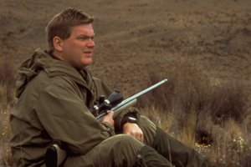
RAY MEARS EXTREME SURVIVAL - series 3 (6 x 60)
AUSTRALIAN PREMIERE
Stars Tuesday December 16 at 9:30pm

Survival expert Ray Mears again packs his rucksack for more adventures around the world. Travelling to remote corners of the planet where conditions are known to be treacherous, Ray meets extraordinary people who have endured perilous situations due to their survival know-how. The series reconstructs their ordeal and explains how to cope in these extreme environments.

His journey takes him into the jungles of Thailand where he meets veterans of the war in Vietnam, to the Naliboki Forest in Belarus where Jews and partisans once took refuge from the Nazis, to Namibia’s parched Skeleton Coast where so many victims of shipwrecks have perished, to Alaska where he relates three amazing tales of survival despite freezing temperatures and isolation, to the Adirondacks in Northern America in the footsteps of a 250-year-old British expeditionary force, and to New Zealand, where one man who lost both legs to frostbite is preparing once more to brave the heights of Mount Cook where he nearly lost his life.

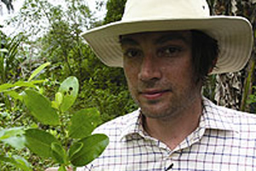
ALEX JAMES: THE COCAINE DIARIES
AUTRALIAN PREMIERE
Wednesday December 31 at 9:30pm

Former cocaine addict, bassist of Britpop band Blur, Alex James accepts an invitation from Colombia’s president to experience first hand the effects of the cocaine industry on Colombia and its people.

Colombia now accounts for 62% of the world’s cocaine production, a trade the UN estimates to be worth US$70 billion worldwide. Today, cocaine has overtaken coffee as Colombia’s top export, producing over 610 metric tonnes a year.
In this very personal documentary, former cocaine addict Alex James, travels to Colombia under invitation of the Colombian president to see first-hand what the cocaine industry is doing to the country and its people.
Now clean, Alex has turned his talents to farming and making cheese so as a farmer as well as a former addict, this visit is both interesting and poignant for him. Once in Colombia, with near-unrestricted access, Alex meets the farmers, the sellers and the enforcers. He visits an anti-narcotics base where the Colombian military are overseeing the chemical spraying of hundreds of hectares of coca plantation and workers are pulling up the plants by hand – a job fraught with danger since the plantations are often land mined and the workers shot. He visits make-shift labs where the coca leaves are made into base cocaine, and he spends time with a dealer and a hitman who tells him business – mostly drug related – is good.
Shortly after, it transpires he has been murdered himself.

Alex admits he spent a million pounds on cocaine and alcohol during the height of Blur’s fame, a fact that is put into sharp perspective when he finds out that a gram of cocaine sells on the Colombian streets for just £1.00 and is the cause of 17,000 murders every year in Colombia. In Colombia, cocaine and violence are inextricable. As Alex himself finds out: “It’s a long way from a cheeky line at a dinner party. It’s terrifying.”

