
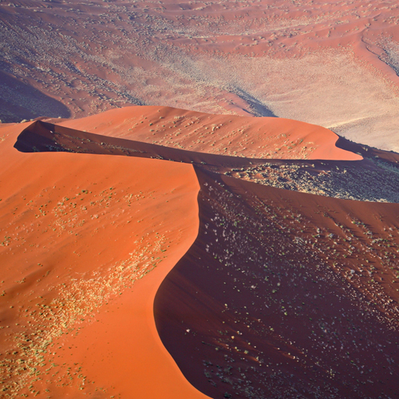

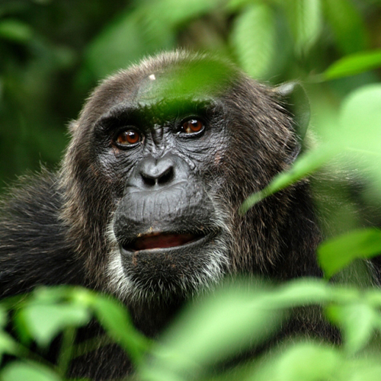
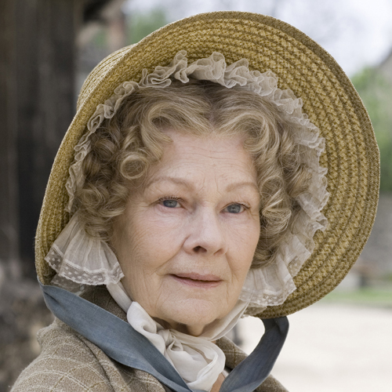

NOVEMBER 2008 PROGRAMMING HIGHLIGHTS Entertainment I Documentaries I Music & Arts

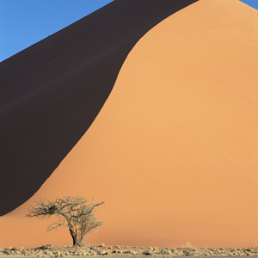
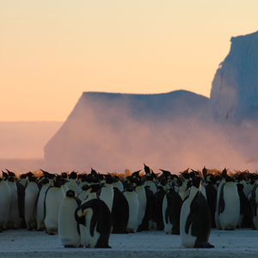
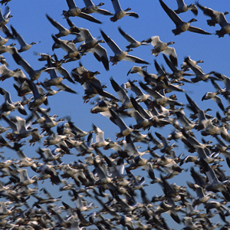
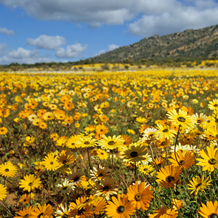
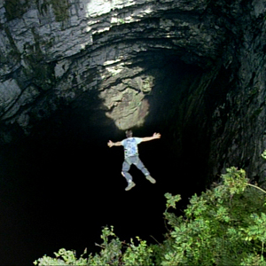
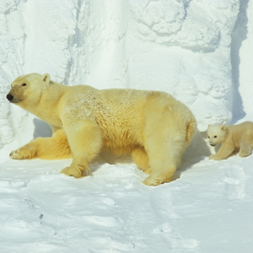
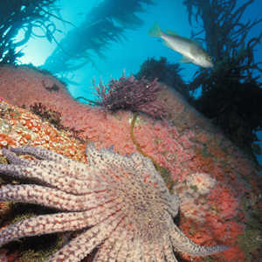
PLANET EARTH
For the First Time on Australian Television in High Definition
Starts Sunday November 2 at 8:30pm

Four years in production, over 2,000 days in the field, using 71 cameramen filming across 204 locations, this is the ultimate portrait of our planet.

Using a budget of unprecedented proportions, Planet Earth’s rich and stunning HD images give you a cinematic experience in your own living room; with the quality of the images every bit as astounding as the content of this epic series. It combines rare action, unimaginable scale, impossible locations and intimate moments with our planet’s best-loved, wildest and most elusive creatures.

Through stunning time-lapse sequences, witness the evolution of environments over thousands of years. CGI is used sparingly, and to breathtaking effect, to take viewers where a camera cannot venture – down an erupting volcano and into the Earth’s core.

From the team behind the multi-award-winning The Blue Planet this is an epic series celebrating the Earth. It’s the definitive look at the diversity of our planet – an emotional and intellectual journey.

We live on a planet of stunning natural beauty. From the towering peaks of Nepal, the lush green of the Amazon, from the dry-sculpted crescents of the Sahara to glistening polar icecaps, our world is truly spectacular.

Episodes include:

Living Planet
Tuning into the Earth’s rhythms – seasons, migrations, food chains, weather systems, day and night – we begin to truly understand our beautiful planet.
Mountains
The Earth’s molten core has dramatically changed the face of our planet, leaving the most beautiful of scars: mountains. Meet their elusive feline inhabitants…
Fresh Water
It’s vital to all life and has the almighty power to carve spectacular landforms: great gorges, canyons and waterfalls.

Caves
Cut off from the world since 1986, the beautiful Lecheguilla Cave in Mexico is properly filmed for the first time.
Deserts
Time lapse photography and starlight cameras capture sand dunes moving and the desert coming alive at night.
Ice Worlds
Spectacular scenery and weather combine with charismatic species in a remote region of unparalleled beauty.
Great Plains
The West African Sahel, grasslands of Mongolia and flooding plains of the Okavango Swamps in Botswana are home to vast herds of animals.
Jungles
Enter the lungs of the planet and watch a rainforest grow over thousands of years.
Shallow Seas
See big dramas and dramatic storms played out in this, the richest area of the ocean.
Seasonal Forests
Visit the giant Sequoias of America to the Baobab of Madagascar and the unspoilt deciduous forests of Eastern Europe.
Ocean Deep
Building on The Blue Planet, the hunt continues for elusive spectacles of the Big Blue.

Planet Earth takes you to places you have never seen before, to experience sights and sounds you may never experience again.

“This is the most awesomely spectacular and wide-ranging natural history series to have hit our screens... Even on a non-HD screen, these images look very special. There’s a clarity and depth that is closer to what we expect to see in a cinema... With the right kind – and size – of HD TV screen, the effect is amazing”
Daily Mail

Director & Executive Producer: Alastair Fothergill, Producers: Andy Byatt, Vanessa Berlowitz, Mark Brownlow, Huw Cordey, Jonny Keeling and Mark Linfield

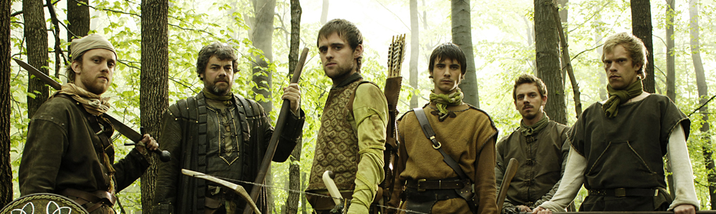
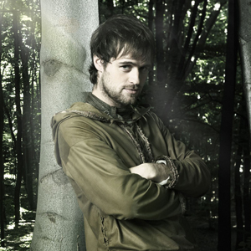
ROBIN HOOD
CHANNEL PREMIERE SIMULCAST WITH UKTV
Starts Tuesday November 18 at 7:30pm

Fun, modern and intelligent, the updated Robin Hood is guaranteed to appeal to all the family with its sharp, witty scripts and a striking new look.

Robin of Locksley heads home from the Crusades to find his people starving and brutalized under the tyrannical rule of the new Sheriff of Nottingham. The home Robin once knew has changed forever, the good Sheriff Edward deposed, and he and his daughter Marian living out their days in exile. Robin quickly discovers that the only way to reason with this Sheriff is with bow and arrow - even if it means sacrificing his title and his lands to Guy of Gisborne and consigning himself to life in the forest.

Along with trusty companion Much, trickster Allan A Dale and passionate Will Scarlett, Robin teams up with forest outlaws Little John and Roy, to help Nottingham’s poor and fight the evil Sheriff’s regime with an arsenal of outrageous scams, disguises, tricks and ingenuity.

Robin finds an ally in Marian, the sweetheart he left behind to fight in the Crusades. Their paths will cross as they bring relief to Nottingham’s oppressed. But as the series progresses and the gang fight on, how long can Marian keep Gisborne at bay, will the Sheriff succeed in cornering Robin Hood, and what will Robin make of the true nature of the alliance between Gisborne and the Sheriff?

Backed by breathtaking archery, incredible swordplay and a smattering of brute force fuelled by an absolute determination to right wrongs, Robin Hood is quiver-full of action, adventure, romance and humour.

Newcomer Jonas Armstrong's Robin is cool, modern and medieval, with a bit of street. Keith Allen (Bodies, The Others) brings his own brand of menace and malevolence to Robin's arch-enemy, the Sheriff of Nottingham. They are joined by an exciting cast of fresh, young talent and established stars. Lucy Griffiths is the strikingly beautiful Marian, and Richard Armitage (North and South) is both handsome and sadistic as Guy of Gisborne, the Sheriff's lieutenant.

Filmed in High Definition on location in Hungary.

