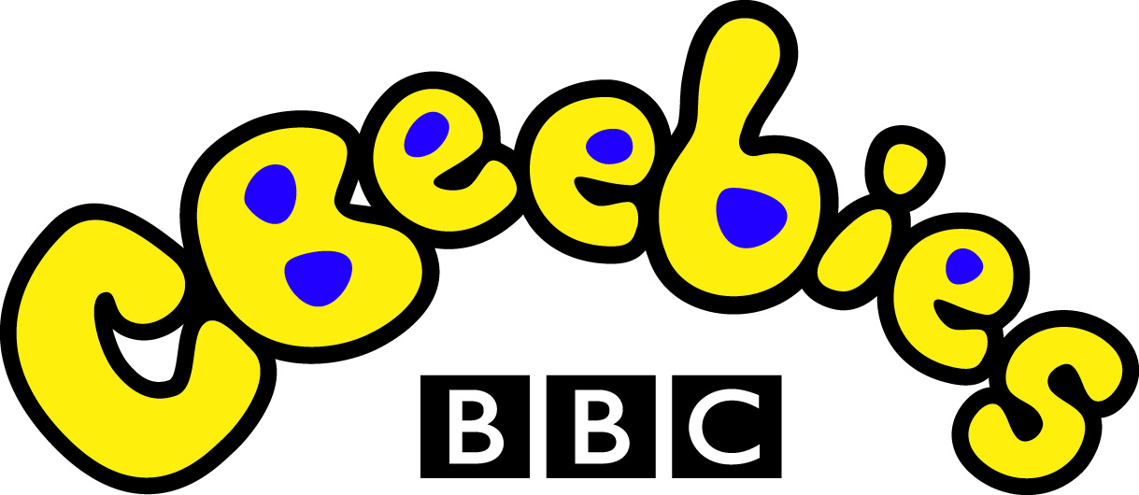
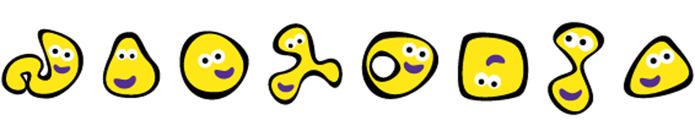

LIGHTING UP LITTLE LEARNERS

NOVEMBER 2008 PROGRAMMING HIGHLIGHTS

CBeebies is Britain’s number one kid’s channel. It is a brightly coloured world where pre-school children aged six and under learn through play. It’s a place full of stories, discovery and fun. It’s where friends like Tinky Winky, Roly Mo, Charlie and Lola combine with colourful effects and clever music to create an innocent, playful experience that keeps young children enthralled.

On CBeebies, your child’s curiosity about the world around them is answered through their zest for play! It’s an interactive environment where ideas grow into imaginative games and exploration opens new doors of language and learning.

In Australia, CBeebies is an advertising-free, safe environment for children. The programming emphasises educational entertainment and is supported by the core BBC values, ensuring it’s trustworthy, reliable and informative.
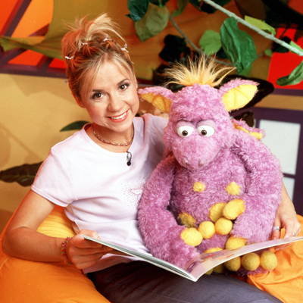
GET SET GO
TIKKABILLA
AUSTRALIAN PREMIERE
Daily at 6:00am

Anything and everything can - and does - happen in this series for pre-schoolers. A song, a story, a rhyme, something to make, a place to visit, music to dance to - Tikkabilla is an eclectic mix of engaging activities. Entering the welcoming and brightly coloured Tikkabilla house, children are taken on a captivating and exciting journey. Along for the ride is the friendly, inquisitive dragon puppet, Tamba, whose enthusiasm for learning rubs off on all those around him. Entertaining, energetic and educational, Tikkabilla is the perfect stepping-stone from learning at home to learning at school for all children.

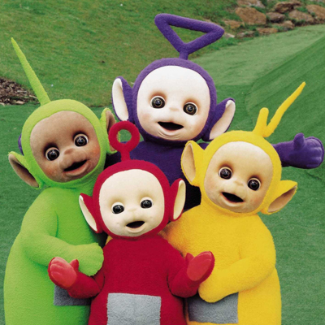
GET SET GO
TELETUBBIES
CHANNEL PREMIERE
Daily at 6:30am

The multi-award winning landmark series starring Tinky Winky, Dipsy, Laa-Laa and Po is loved by children all around the world. These four bouncy, colourful characters with video screens in their middles live in a sunny, futuristic land which appeals to toddlers just like them; they too take pleasure in simple games, and delight in experimenting with speech and repeating simple phrases like “eh-oh!”, “big hug” and “bye-bye”.

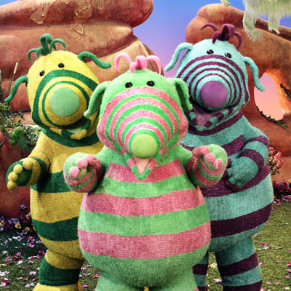
GET SET GO
FIMBLES
CHANNEL PREMIERE
Daily at 7:40am

Come with us to a magical place, a hidden valley where three very special stripy creatures embark on never-ending journeys of discovery and wonder. This is a world where imagination is limitless. This is where the Fimbles live - Fimbo, Florrie and Baby Pom - and all their friends too: Bessie and her baby chick Ribble, who vibrates when he's happy; Roly Mo, the wise, gentle mole; and Rockit the frog, whose energy and humour lead to heaps of hilarious adventures.

The Fimbles have a unique talent of finding things and in anticipation of a new discovery, they get the Fimbling Feeling - their fingers twinkle and their noses twitch. These finds, anything from a manmade object such as a button, to a natural object like a feather to something more abstract like the colour blue, provide the starting point for a rich tapestry of songs, stories, activities and imaginative play, making Fimbles a new learning experience every time.

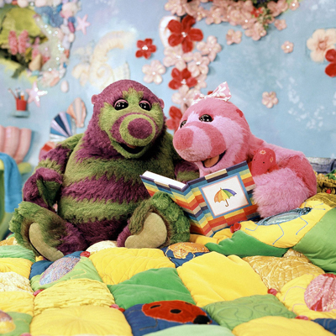
GET SET GO
THE ROLY MO SHOW
AUSTRALIAN PREMIERE
Daily at 8:00am

Join Roly Mo, the kind, cheerful mole with a passion for books, stories, games and activities that entertain as well as educate.

Set beneath Fimble Valley in Roly’s cavernous, underground home, this show helps young viewers to discover the magic of reading. Roly has a story or rhyme for every occasion and that’s just as well as his inquisitive young niece, Little Bo, is never far away. Keen to learn, and bursting with excitement, Little Bo explores the big wide world with the help of her uncle’s vast collection of books stored in his library.
Also eager to be included in the adventures are the boisterous and naughty, but extremely loveable, Yugo and Migo – rare, underground creatures, called ‘snoots’. The curious snoot twins provide much of the slapstick comedy in the show.

Some familiar Fimble friends are also on hand to join in all the fun – Rockit drops in from time to time and Ribble makes an appearance, too.

With delightful and warm-hearted characters, and the same ingredients that have made Fimbles such a phenomenal worldwide success, The Roly Mo Show is sure to win a place in the hearts of all young viewers...

GET SET GO
HARRY AND TOTO
AUSTRALIAN PREMIERE
Daily at 8:15am

Can you spot the opposite? That's the question in the show that looks at the world from two angles. Harry and Toto are best friends but they're also very different. When they play together, they find opposites. Harry is a hare who is really fast while Toto is a tortoise who is very slow.
Opposite Town is also full of animals ready to lend a helping hand or give advice. Once Harry and Toto realise there are two sides to a problem, it's down to the odd couple to find a way of settling their differences and getting on.

DISCOVER AND DO
BOOGIE BEEBIES
AUSTRALIAN PREMIERE
Daily at 1:00pm

Boogie Beebies, the energetic preschool dance show that encourages children to have fun with dance and uses action words – stretching, twisting, swishing – to allow them to express themselves through their bodies. The Boogie presenters, Nataylia and Peter, take children through a sequence based on good educational dance practice. Each programme introduces a new theme, such as the sea, and children start with a warm up, involving bending, stretching and twisting. The theme is then explored through dance with fun routines like the Ocean Motion, Space Walking and the Lemon Zip Skip, and ends with a gentle cool down.

In every episode, children learn the routine, ready for a 'Big Video' - a pop video in which the children, including the viewers - are the stars.

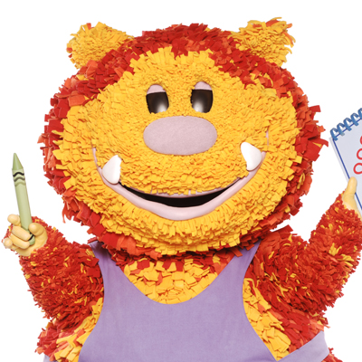
DISCOVER AND DO
GET SQUIGGLING
AUSTRALIAN PREMIERE
Daily at 1:15pm

Welcome to Squiglet's world. It's plain white. But it doesn't stay like that for long! With the help of a magical set of crayons that he calls Squiggle Sticks, Squiglet shows how to draw colourful characters. When Squiglet and the viewers sing the magic words together, the character leaps off the page and comes to life! This visually unique, truly interactive show for two to five year olds is a mix of full body puppetry, animation and live action. And long after Squiglet has waved goodbye, they'll still be drawing new adventures in their very own Squiggle Pads!

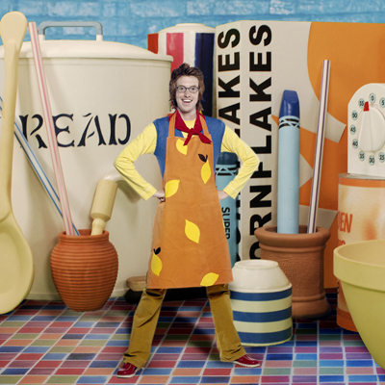
DISCOVER AND DO
BIG COOK LITTLE COOK
AUSTRALIAN PREMIERE
Daily at 1:30pm

Take a seat in the cafe and enjoy a comical blend of lively songs, unusual visitors and inventive recipes provided by big cook Ben and little cook Small. While Ben is the size of any human, Small is only 40cm tall! Using his size to good effect, Small is an expert at finding the right ingredients and putting the decorations on recipes such as jam tarts, monster muffins and clown cakes. But he'd better watch out, or he'll get a dusting of flour or a dollop of gooey mixture landing on him. Whatever their tastes, pre-schoolers are bound to love this engaging and accessible mix of food and fun.


BIG FUN TIME
UNDERGROUND ERNIE
AUSTRALIAN PREMIERE
Daily at 2:45pm

Modern, fun, urban and cool, Underground Ernie is a new, cutting-edge children's series that will capture the imagination of children and adults alike. Ernie is controller of International Underground - it's his job to make sure all the trains on the underground are running. But Ernie can't do this all on his own. He's helped by his two friends Millie and Mr Rails. The series features train characters like Bakerloo and Victoria - and visits from international trains like Moscow and Osaka.

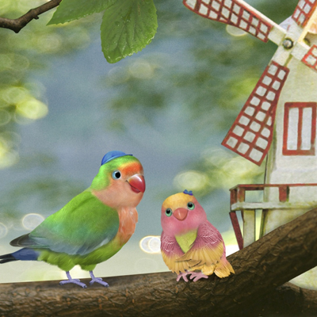
BIG FUN TIME
3rd & BIRD
Daily at 5:45pm
AUSTRALIAN PREMIERE

The vibrant treetop community of 3rd & Bird is alive with singing, whistling and dancing. Each beautifully crafted episode is filled with music and songs revolving around the lives of Samuel and Muffin Lovebird and their friend Rudy, who live, learn and play in the branches of a beautiful old tree.

Each episode will see Samuel and Muffin encountering a problem relevant to the pre-school age, such as makin g a new friend, learning a new skill or going somewhere for the first time. Through the stories told in the series about diversity, tolerance or perseverance, it will help children to develop social skills that are integral to the functioning of a healthy community.


BED TIME HOUR
THE STORYMAKERS, series 1
AUSTRALIAN PREMIERE
Daily at 6:00pm

The scene is set in a library where, after it closes at midnight, the magical Wordsworth family and puppets, Jelly and Jackson, pour objects and ideas into a story-making machine. This machine always needs the magical ingredient, and this is - imagination!
The programme encourages children to develop a love of books. Parents/carers might like to take children to their local library, look at books and magazines together, or invent their own lively stories.

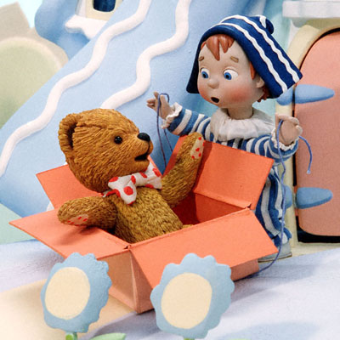
BED TIME HOUR
ANDY PANDY, series 1
CHANNEL PREMIERE
Daily at 6:15pm

Welcome to the candy-coloured world of Andy Pandy and his best friends Looby Loo and Teddy. A world filled with endless fun and games played under cornflower blue skies. Each of the playmates live in their own special little house reflecting the characteristics of its inhabitant. Andy Pandy's house has a roof just like his blue-and-white hat. All the homes are situated around a small shared garden where their games and adventures take place. Andy Pandy is the pivotal character who happily plays all sorts of games with his playmates, from learning how to count to finding Looby Loo's lost hair ribbon. The friends are often joined by other inhabitants of this candy-coloured world who emerge from their homes to join in the fun. There's the draught excluder snake who resides in a suitably skinny house made of drainpipes and the purple plush dog who lives in a very smart kennel. There's the ball who bounces and rolls the whole day and still comes back for more, and the sailor who is inseparable from his boat.

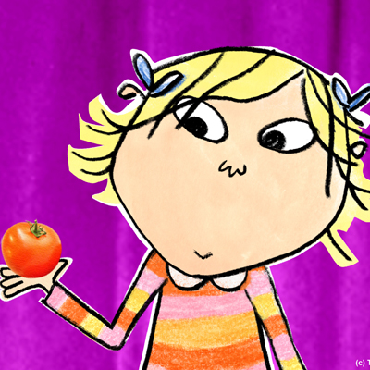
BED TIME HOUR
CHARLIE AND LOLA, series 1
CHANNEL PREMIERE
Daily at 6:20pm

"I have this little sister Lola. She is small and very funny..."

Lola is four and she "will not ever, NEVER eat a tomato!" Sometimes she is "not sleepy and she will not go to bed", and how will she cope when she is really ever so ill and may never smile again? It falls to big brother Charlie to win her round, and he uses every trick in the book - logic, humour, and the power of the imagination. Eating yucky, sticky mashed potato instantly becomes an expedition to the top of Mount Fuji tasting spoonfuls of cloud fluff. And tomatoes? They're really moonsquirters from the land of Moon!

Using 2D CelAction animation, paper cutout, fabric design, real textures, photomontage and archive footage, all the distinctive style and exuberance of Lauren Child's award-winning picture books come to life. Glorious music and sound effects help to conjure up fantastical worlds that only children could invent, while realistic dialogue, voiced by children, ensures these magical adventures really resonate with kids.


BED TIME HOUR
BRUM, series 3
CHANNEL PREMIERE
Daily at 6:40pm

Super-brave superhero, Brum zooms into the Big Town and always saves the day by performing amazing stunts and fearless feats, whether he's rescuing the crazy residents of the Big Town from mischief and mayhem or capturing hapless baddies. Children love heroes and who better for them to cheer and imitate than super-action hero Brum, full of confidence and reassurance, so important to the younger generation growing up in this fast-changing world.


BED TIME HOUR
JACKANORY JUNIOR
AUSTRALIAN PREMIERE
Daily at 6:45pm

Aimed at four to six-year-olds, Jackanory Junior draws young children right into the heart of stories from some of the best modern authors. From Geraldine McCaughrean’s re-telling of Gulliver’s Travels to Jeremy Strong’s wacky story of a pirate school, children are transported into magical make-believe worlds where anything can, and often does, happen. Beautiful animation brings the books’ illustrations to life while the stories are told by some of the best and most endearing British acting talent including Martin Clunes, funnyman Kris Marshall and the Oscar-nominated Sophie Okonedo.

