
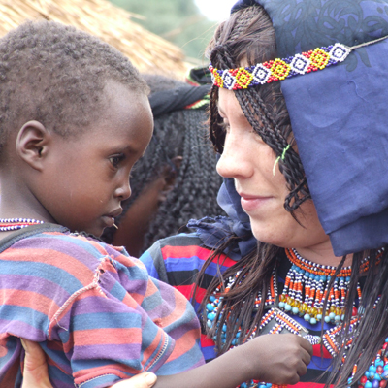

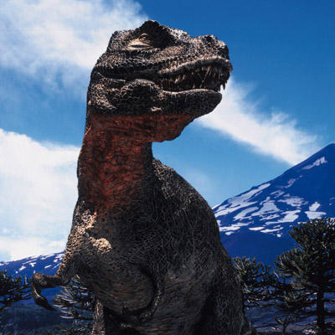
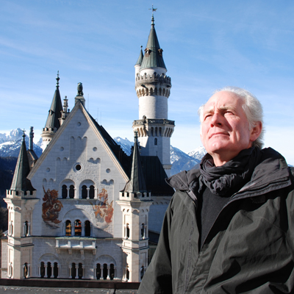
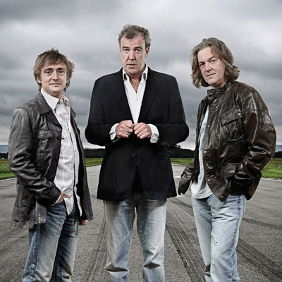
NOVEMBER HIGHLIGHTS 2008 Entertaining Brains

On BBC Knowledge facts are made fascinating and the truth can be more entertaining than fiction! It will entertain your brain if you have an unarticulated need to know.

Showcasing award-winning documentary and non-fiction programmes, BBC Knowledge brings the world to the screen with colour, passion, sensitivity, candour and depth. Presented by charismatic experts who know how to lift the lid on their subjects and reveal all the underlying wonder of the world, BBC Knowledge is a captivating proposition for the endlessly curious.

BBC Knowledge programming strands:

The World visits cultures from around the world and explores events that have defined us.
Science & Technology showcases new frontiers, from space to motoring, medical miracles to building marvels.
On People explore the human body and mind, and witness how inspiring humanity can be.
The Past brings historical events, places and people back to life.
Business offers invaluable advice to help stay on top of today’s challenging business world.


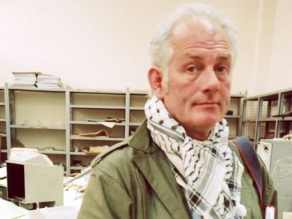
DAN CRUICKSHANK’S RAIDERS OF THE LOST ART (1 x 60)
AUSTRALIAN PREMIERE
Saturday November 1, 2008 at 6:30pm
Iraq’s unexpected war casualty

In April 2003, while American troops stood by, unable or unwilling to act, one of the world's greatest archaeological collections was ransacked. So ran the headlines at the time. But now a different picture is emerging of the looting of the National Museum in Baghdad

Architectural historian and adventurer, Dan Cruickshank flies back into the heart of a still-smouldering war zone to find out what happened to the antiquities. Granted unprecedented access to the museum and the ongoing American investigation, he is the first journalist to enter the Baghdad museum since it was looted. As he tries to discover the full extent of the damage and theft, he meets with half-truths, obstruction and aggression.

Empty cases and broken glass are all that is left of the priceless collection of artefacts from the great ancient civilisations. Or so it would appear. However, Cruickshank reveals that only a few dozen significant pieces, not thousands as originally reported, were stolen. And many may have gone missing long before the Americans arrived in the Iraqi capital.

The Raiders Of The Lost Art offers an urgent, compelling view of an international news story from its very heart, and presents both a complex human drama and a vivid and shocking view of culture very much in the frontline.

”The best post-war film on the sacking of the Baghdad museum … Cruickshank went at it like an Agatha Christie amateur sleuth. It was sensationally good TV: engrossing, exciting and informative, as well as being a parable.” Sunday Times (A A Gill)

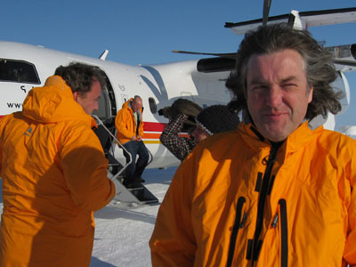
TOP GEAR POLAR SPECIAL (1 x 60)
CHANNEL PREMIERE
Saturday November 1, 2008 at 7:30pm

It’s the ultimate test of man against machine – or should that be dog against machine – as the Top Gear team set out on their most ambitious and arduous challenge to date.

Jeremy Clarkson, James May and Richard Hammond take part in a Polar Special. It is an epic land race starting in the town of Resolute, Northern Canada finishing 450 miles later at the Magnetic North Pole.
The terrain they tackle is some of the toughest on Earth – a mix of mountainous land masses and jagged sea ice where temperatures can drop to a mind-numbing minus 65 degrees Celsius. And then there are the polar bears. The Arctic is home to 80 per cent of the world’s polar bear population and, when it comes to lunch, they really don’t care if it’s seal or human.

This being Top Gear, the three presenters’ modes of transport are a little out of the ordinary. Jeremy and
James, of course, drive. Their vehicle of choice has been specially converted for the task by an Icelandic engineering team whose achievements include the first crossing of the Greenland Ice Cap by car.
Richard travels on something a little less hi-tech – a sled pulled by a team of 10 Canadian Inuit dogs.
Richard’s human companion is Matty McNair, a hugely experienced Polar explorer who has an almost telepathic understanding of her dogs.

Pitting dog power against horse power may sound like a one-sided contest but, given the nature of the terrain, there’s no telling who will make it to the pole first. In fact, there’s no guarantee that either team will make it to the finish line at all…

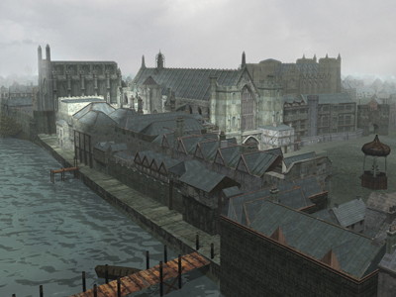
THE GUNPOWDER PLOT (1 x 60)
AUSTRALIAN PREMIERE
Saturday November 1, 2008 at 8:30pm

This is the story of the first major terrorist attack – an attempt to blow up the symbolic heart of one of the world’s major capital cities. Set against a backdrop of religious strife, enemies within and a conspiracy by the security forces and featuring Top Gear’s Richard Hammond.

Welcome to London in 1605. Just two years into the reign of King James I, a group of young disaffected Catholics become so desperate that they feel their only route to change is to rid themselves of the monarchy and Parliament. With three and a half tons of the most destructive explosive available at the time, they come within minutes of the total destruction of England’s Houses of Parliament.

Now 400 years on, this is a timely re-assessment of the story behind the Gunpowder Plot – one of the most famous yet least understood events in history. In the wake of 9/11 and the war on terror, the Gunpowder Plot has a chilling new relevance. Modern parallels have become impossible to ignore.
How could a group of young Englishmen become so radicalised and so hell-bent on mass murder at any price? What was their endgame had they succeeded? Did King James’s right-hand man, Sir Robert Cecil, know of the plot all along and seize upon it as the perfect device with which to crush the Catholics?

A cast of internationally reputed experts re-assess the plot. State of the art CGI shows the extent of the damage if the explosion had taken place, and dramatic reconstruction reveals the men behind the plot.

The Past
IN SEARCH OF MYTHS & HEROES (4 x 60)
CHANNEL PREMIERE
Monday November 3, 2008 at 8:30pm

Follow Michael Wood as he goes on a series of romantic and compelling journeys into the past. Seeking the truth behind four of the most famous myths – Shangri-la, the Golden Fleece, the Queen of Sheba and the Holy Grail – he journeys across the planet from the stunning landscapes of Western Tibet, to the mountains of Georgia and the Caucasus, to the plains of Southern Iraq and to the coast of Ethiopia. His travels also take in India, Nepal, Greece, Egypt and the ancient worlds of Celtic Britain and Ireland.

Shangri-la
There is an Indian legend about a lost civilisation beyond the Western Himalaya, where the ancient wisdom of humanity was preserved for the future. The legend has been immortalised in both a book and a film – but was there a real Shangri-la?

The Queen of Sheba
Who was the Queen of Sheba? Her story is found in both the Koran and the Old Testament. Her beauty, wealth and intelligence are the stuff of legend, and she is still revered in Ethiopia today. But how was she involved with King Solomon and the Ark of the Covenant, and was she really the founder of the Ethiopian nation?

The Golden Fleece
Jason and the Argonauts’ search for the Golden Fleece is the ultimate quest – older even than Homer’s Iliad and the Odyssey. The idea of the hero’s quest is at the centre of many human stories from the earliest literature to the latest Hollywood epics. But was there really an expedition beyond the limits of the known world, to find the fleece of a golden ram that had carried two children to safety?

The Holy Grail
The cup of Christ is the ultimate religious symbol. But how did Christ’s cup from his last supper come to be connected with Arthur, the legendary king of Britain and was there really a grail or even a true King Arthur? And why does the idea of the grail still captivate us today; from the New Agers and the Mystics; to Monty Python and Indiana Jones?

Written and presented: Michael Wood (Story of India, In Search of the Trojan War, Alexander the Great, Conquistadors)
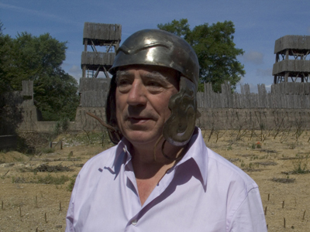
The Past
TERRY JONES BARBARIAN LIVES (4 x 60)
AUSTRALIAN PREMIERE
Monday November 3, 2008 at 9:30pm

Victims of a well-oiled propaganda machine, the Celts, Huns and Goths – among others – have endured thousands of years of misrepresentation. As Terry Jones reveals, the image of brutal savages hell-bent on nothing more than slaughter, pillage and rape, handed down to us by the Romans, is little more than a monumental exercise in ancient spin.

In an epic journey from the misty bogs of southern Ireland to the arid deserts of Persia, Jones exposes the depth of this Roman deception, bringing the fabulously rich and varied ‘barbarian’ cultures back to life; exploding myths and setting records straight wherever he goes.

These ‘barbarians’ were the ‘bogeymen’ who stalked the dark corners of the Roman psyche, derided as “absolutely mad about war... otherwise simple”. But were they really that different from the Romans themselves? As one of the most dominant empires the world has ever known, the Romans wrote their own history. But recent archaeological evidence has revealed a completely different story to that of Roman propaganda.

The Celts wore beautiful clothes and jewellery; their society was complex and sophisticated; they made their own roads and calendar. Human rights, female freedom and flower arranging were all part and parcel of Persian society. The Goths used their knowledge of Roman military training and tactics to inflict a series of devastating defeats on Rome. And the Dacians – the now extinct indigenous people of what is modern day Romanian – were not only teetotal but they had their own unique religion.

None of theses facts fit with how the Romans have led us to perceive these ‘barbarians’. It seems Rome’s mission to civilise the ancient world was little more than a cynical and well organised looting; that the ‘Glory of Rome’ was built with barbarian wealth, blood and sweat. Is it time to re-write the history books? Were the Romans the real barbarians?

Presenter: Terry Jones (Monty Python, The Crusades; Terry Jones Medieval Lives)

Additional information available.

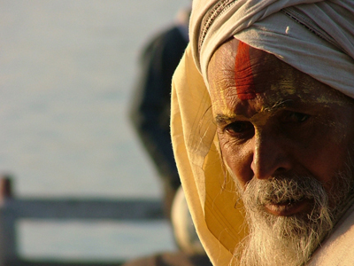
World
STORY OF INDIA (6 x 60)
CHANNEL PREMIERE
Tuesday November 4, 2008 at 7:30pm

For over two millennia, India has been at the centre of world history. But how did India come to be? What is India? In this landmark six-part series, historian Michael Wood embarks on a dazzling and exciting journey through today’s India, looking to the present for clues to her past, and to the past for clues to her future.

The world’s largest democracy, a nuclear power and a rising economic giant, India is now as well known across the globe for its domination of job outsourcing and computer technology as it is for its many-armed gods and its famous spiritual traditions. But India is also the world’s most ancient surviving civilisation, with unbroken continuity back into prehistory.

Charismatic and informed presenter Michael Wood brings his trademark insight and infectious enthusiasm to The Story of India, chronicling the incredible richness and diversity of the subcontinent’s peoples, cultures and landscapes; the originality and continuing relevance of its ideas; the intense drama of its past and some of the most momentous and moving events in world history.

Written and presented: Michael Wood (In Search of Myths & Heroes, In Search of the Trojan War, Alexander the Great, Conquistadors)

Additional information available.
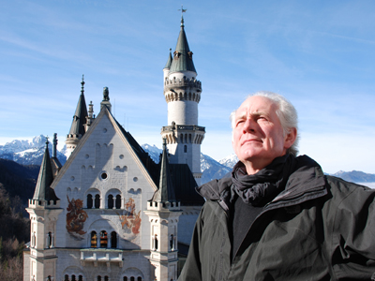
World
DAN CRUICKSHANK’S ADVENTURES IN ARCHITECTURE (8 x 60)
AUSTRALIAN PREMIERE
Tuesday November 4, 2008 at 8:30pm

What do the buildings we construct say about us as people? Dan Cruickshank offers a history of humanity through architecture. This affirmation of the human spirit celebrates architecture as the richest and most complex of creative activities.

In each programme, buildings from all over the world are dramatically juxtaposed, revealing unexpected connections between very different types of architecture. From the Kizhi Cathedral in remote north-west Russia to the convent of St Catherine in Sinai, Egypt, and themes that range from beauty, to power, paradise and pleasure, this series examines an expanse of buildings and themes.

The buildings Dan visits are ones with gripping stories – stories that build as Dan explores the country around the building, as well as the building itself. He takes part in the life of the place, delves into its rich culture and meets locals and authorities on the buildings.

It’s a monumental journey that takes in some monumental structures, gradually building an architectural knowledge so that, through the series, a story of world architecture is told.
World
RAY MEARS EXTREME SURVIVAL (6 x 60)
AUSTRALIAN PREMIERE
Tuesday November 4, 2008 at 9:30pm

Survival expert Ray Mears again packs his rucksack for more adventures around the world. Travelling to remote corners of the planet where conditions are known to be treacherous, Ray meets extraordinary people who have endured perilous situations due to their survival know-how. The series reconstructs their ordeal and explains how to cope in these extreme environments.

His journey takes him into the jungles of Thailand where he meets veterans of the war in Vietnam, to the Naliboki Forest in Belarus where Jews and partisans once took refuge from the Nazis, to Namibia’s parched Skeleton Coast where so many victims of shipwrecks have perished, to Alaska where he relates three amazing tales of survival despite freezing temperatures and isolation, to the Adirondacks in Northern America in the footsteps of a 250-year-old British expeditionary force, and to New Zealand, where one man who lost both legs to frostbite is preparing once more to brave the heights of Mount Cook where he nearly lost his life.

Additional information available.

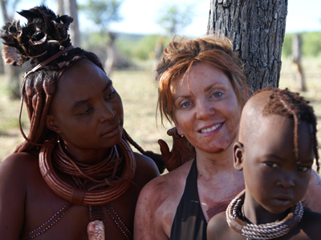
People
TRIBAL WIVES (6 x 60)
AUSTRALIAN PREMIERE
Wednesday November 5, 2008 at 8:30pm

Six British women get to grips with new lifestyles, families and communities in some of the world’s most remote tribes to find out whether ‘West is best’.

The women are expected to spend up to a month living with their new families, fully immersing themselves into their new culture. Each woman must work, eat and sleep exactly as the other tribal women in order to experience what it is really like to live as a member of their community.

In turn, the series reflects on the tribe’s perception of Western culture and garners their views on their visitors: members of the tribe are interviewed each week to assess how well each woman is integrating into the community, how useful she is and the strength of the individual relationships she forges.
Crossing continents to some of the most remote places in the world – from jungle to desert – viewers follow the progress of each tribal wife to see if she is accepted by the community. Will she rise to the challenges thrown at her – or will she simply miss her Western lifestyle too much?

